Generating DC High Voltage Using Marx Generator

Our project proposes high voltage DC generation using Marx generator principle that uses MOSFET along with capacitor stacks.
The marx principle was brought by Erwin Otto Marx. The principle consists of generating a pulse of high voltage by using a number of capacitors parallely in order to charge up to ontime and then set up in connection series to develop a high voltage during the off period. The system is used in the process of generation of in Kv’s for real time testing to be carried out on electrical appliance insulation effectiveness to be put up on power carriers. The system consists of four different stages such that each one is made up from two diodes, one MOSFET along with one capacitor.
Diodes are used in capacitor charging at each stage and MOSFET is used as a switch to avoit power losses. The capacitors are charged in paralled during the ON time using 555 timer. The capacitors are brought in a series using MOSFET switches during the OFF time.
At the end the number of capacitors used in series sums up the total voltage to approx 3.2 times voltage supplied. Our project provides a compact and easy system from a DC supply of 12 V to get an approx (30 – 36) Volts.
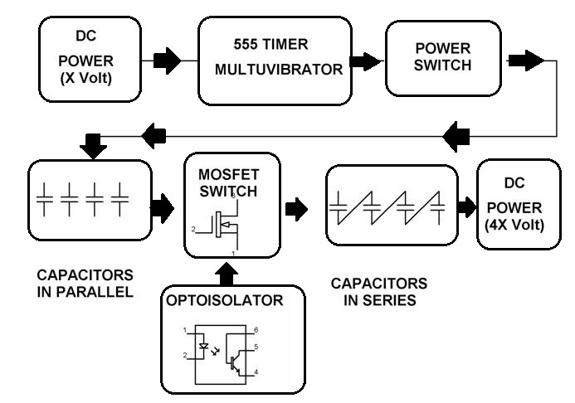

Hardware Specifications
- Diodes
- Optoisolator
- Capacitors
- MOSFET Switch
- DCPower Supply
- 555 Timer Multuvibrator
- Resistors
- Diodes

